Assignment – 6

* **Configuration of Virtual LAN(VLAN).**
* Procedure:

Step 1 : Take 3 Switch, 18 PC’s

Step 2 : Connect each Switch with 6 PC’s and connect Switches with each other

with Copper Stright-Through wire and Copper cross-over wire.

Step 3 : Assign IP Addresses to the PC’s and each of them belongs to class C

Step 4 : Configure one Switch and export the configuration file to another Switch

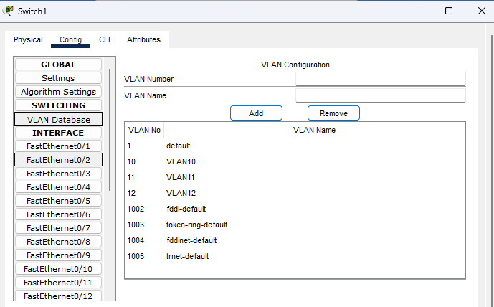

Step 4 : Enter the VLAN ID at VLAN Number and give a VLAN Name and then add

And add three VLAN with different VLAN Number

Step 5 : After that enable interface and select the VLAN for this port or interface

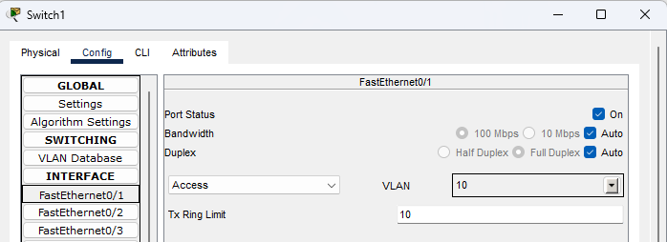

Step 6 : After that make interface Trunk which connected with others Switch

Interface or port like this:

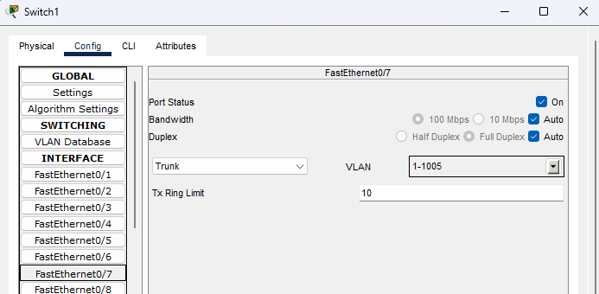

Step 7 : After that export the configuration file and merge with another Switch

and everything is set and we check the response is coming or not.

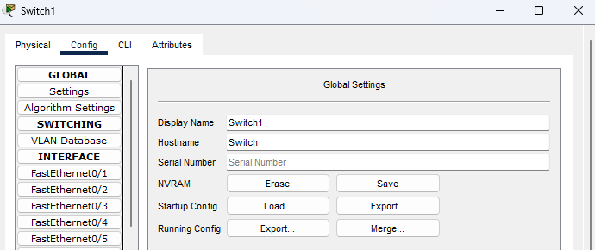

* 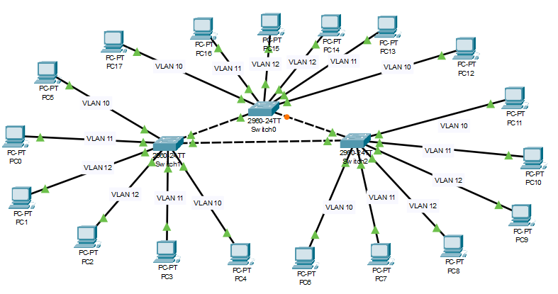Diagram:
* Output’s:

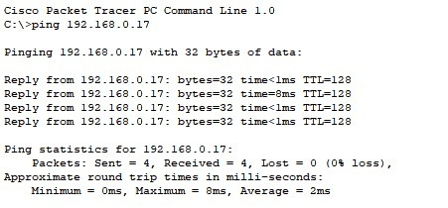

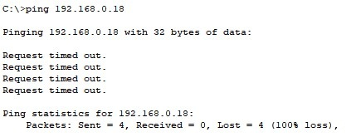

Response coming from same VLAN PC’s but in different VLAN PC’s are not so VLAN configuration is successful.